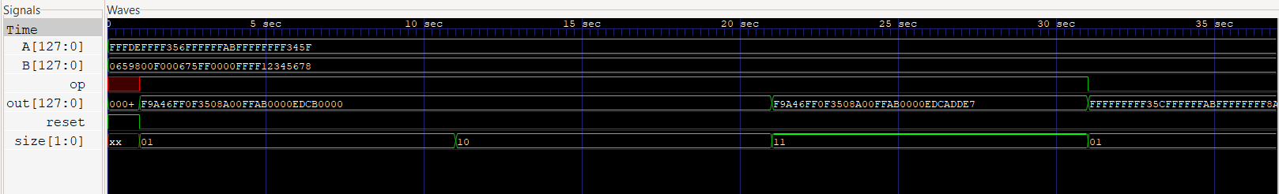
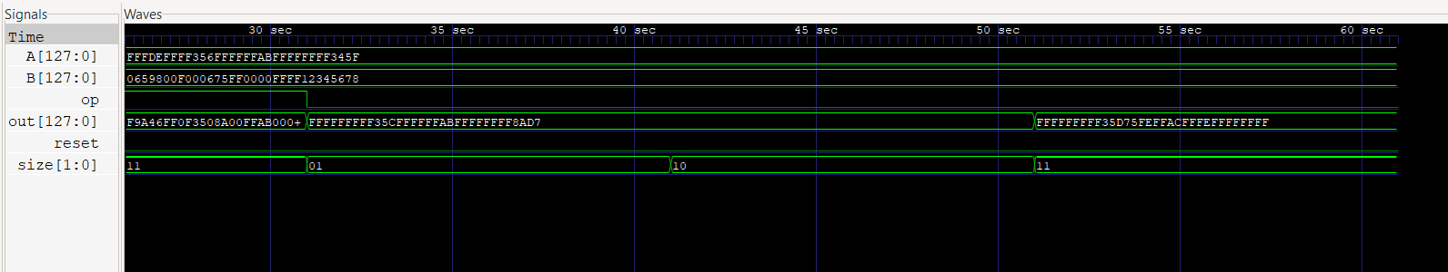
Working on it
Very easy question understanding wise , what caught me off-guard was all the processes happening simultaneously.
Thought over it for days. 1st thought writing all of the slicing and operations individually but was too lazy for it so didn’t go ahead with it. thought of ways to shorten code and stumbled upon functions also being part of Verilog.
loop was on my mind but my understanding of loops was all of the process happens one after the another and not simultaneously. Then I searched working of for loop in Verilog and came to know for loops under always block goes thorough with all the iterations at the same time
after that with functions I was able to finish the code in 3 for loops.
The lanes of the reg were done through slicing. Keeping case condition as size the slicing was done accordingly.
Could’ve used clock to sync the processes but kept it simple as the problem didn’t specify it.
Used only one set of A and B as making and verifying is tedious. Saturation is very evident as A is exceptionally large.2 hexa units represets 8 bits and 4 16 and 8 32.

